Victorian Curriculum F–10 links:
Levels 5 and 6
Science
Science Understanding
Science as a Human Endeavour
Scientific understandings, discoveries and inventions are used to inform personal and community decisions and to solve problems that directly affect people’s lives
Chemical sciences
Solids, liquids and gases behave in different ways and have observable properties that help to classify them

Activity: How does the Western Treatment Plant work? (Years 5 and 6)
  - From past to present—at the Western Treatment Plant

Students explore the key processes used to treat sewage and develop a flow chart to describe the process.

Duration
Two-hour session

Equipment
Interactive whiteboard or data projector

Activity steps
- Review student ideas about treatment processes at the Western Treatment Plant. Watch the Where does wastewater go? ABC Splash video [3:42] at <http://splash.abc.net.au/home#!/media/524873/>
- Ask students to describe which of the processes they correctly predicted they would expect to find at the Western Treatment Plant. Ask students to describe differences between what they expected to see and what they observed in the video. Refer to the Y chart of what they thought they would see, hear and smell. Update the chart with new ideas in a different colour.
- Using the information on the Sewage treatment process web page at <http://www.melbournewater.com.au/whatwedo/treatsewage/wtp/Pages/Sewage-treatment-process.aspx>, lead the discussion to identify and elaborate on the key processes of sedimentation, aeration and evaporation. Show the animations listed in the Resources below to explain how micro-organisms (bacteria) enable the plant to treat water without chemicals. Key questions may include:
- How are large solids such as plastics and rags removed from sewage? (Sludge settles; the process is sedimentation.)
- What happens to the solids in the large pond? (Sludge settles; the process is sedimentation.)
- Why is one pond covered over with black plastic? (Bacteria in this pond feed on the sludge without oxygen and they produce methane gas when they break down the sludge. Waste gases are captured reducing smells and harmful greenhouse gas to the atmosphere).
- How is the waste gas used? (Methane is the waste gas captured and used to generate electricity to run the plant.)
- What happens to the sewage as it travels through the pond system? (Bacteria continue the process to break down the sewage. The sun evaporates some of the water, which enters the atmosphere as a vapour and becomes part of the water cycle.)
- What role do the big beaters play? (Provide oxygen; the bacteria in this pond need oxygen to feed on the sewage and break it down to remove nitrogen. The process when oxygen is mixed into the water is called aeration.)
- How are the bacteria removed from the water? (As the treated water passes through the ponds bacteria-filled sludge settles to the bottom and is collected and reused in the activated sludge plant in pond 5. In shallow water, ultraviolet (UV) light from the sun helps control harmful (pathogenic) bacteria. The ultraviolet light affects the bacteria causing them to lose their ability to reproduce and therefore die out.)
- What role do algae and zooplankton play in the treatment process? (Algae are microscopic green plants that use the sun’s light to grow. They produce oxygen and take up nutrients such as nitrogen. In turn, algae are eaten by zooplankton (microscopic organisms). Birds also feed on algae and zooplankton.)
- Why is the treatment process considered to be a natural one? (The bacteria are used to remove organic matter from the sewage rather than harmful and expensive chemicals.)
- Distribute the Student worksheet: Treating sewage. Students use the worksheet to create a flow chart of the treatment process. They could complete the activity as a poster adding their own text to describe the processes. Alternatively, the images could be provided electronically for students to use with presentation software.
Reflection
- Students compare their completed flow chart with their labelled diagram developed in the pre-activity. They use the two representations to describe their learning.
Note: This task could be used for assessment purposes to assess student understanding of the processes used to treat sewage. Key processes include sedimentation, evaporation and aeration.

Teacher background
Sewage treatment is a completely natural process using biological organisms rather than chemicals. The purpose of sewage treatment is to remove:
- organic matter
- suspended solids
- nutrients
- disease-causing organisms.
At the completion of the process only liquid effluent remains. This effluent is provided for various land uses or released to the ocean.

Resources
Where does wastewater go? ABC Splash
<http://splash.abc.net.au/home#!/media/524873/>
Western Treatment Plant, Melbourne Water
Primary treatment of sewage and anaerobic treatment of sludge
<https://www.youtube.com/watch?v=--GS_djOzcg&list=PL1zDcvEb76G6FdTMg-_VRmAE4jMoarrKr&index=1>
Secondary treatment of sewage
<https://www.youtube.com/watch?v=yF9hQUebDNA&index=2&list=PL1zDcvEb76G6FdTMg-_VRmAE4jMoarrKr >
Tertiary treatment of sewage at the Western Treatment Plant

<https://www.youtube.com/watch?v=_v39CRr8gGY&list=PL1zDcvEb76G6FdTMg-_VRmAE4jMoarrKr&index=4

Student worksheet: Treating sewage
Use these images to create a flow chart to describe how sewage is treated at the Western Treatment Plant.
Note: Provide images in random order.

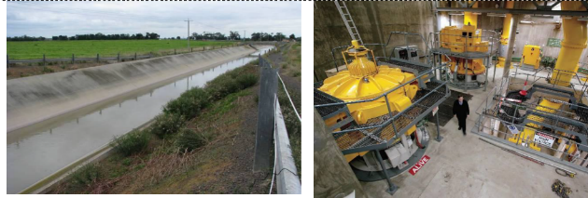

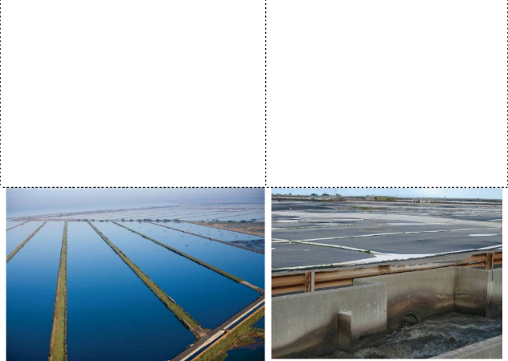
Effluent entering Western Treatment Plant Pumping station

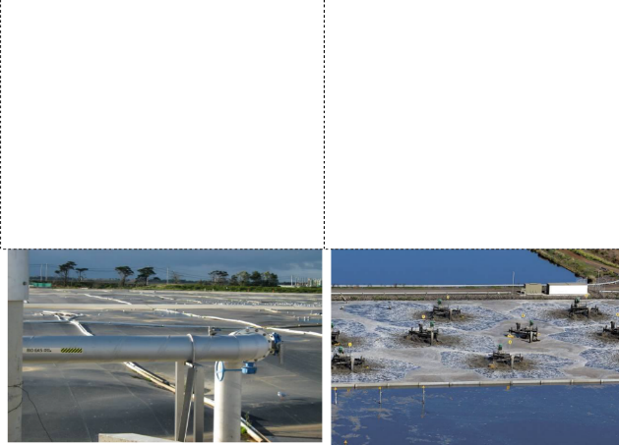
Ponds where water is exposed to sunlight Ponds where sedimentation takes place

Ponds covered with black plastic to capture methane
Mechanical beaters

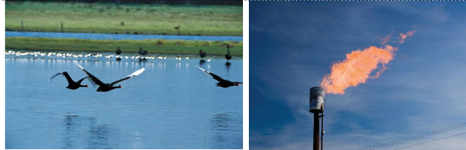

Conservation lagoon Excess methane gas being burned
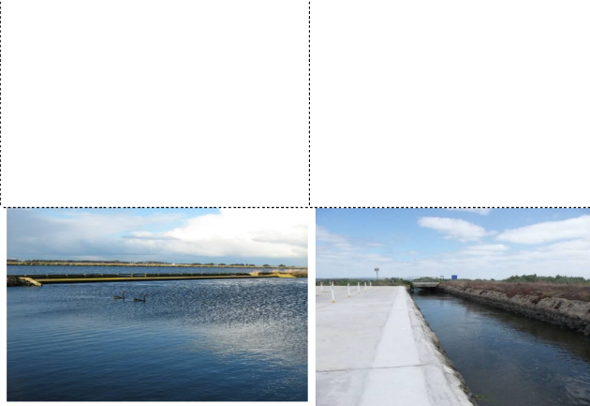

Weir where water flows from one pond to another via gravity flow
Open channel leading out to Port
Phillip Bay

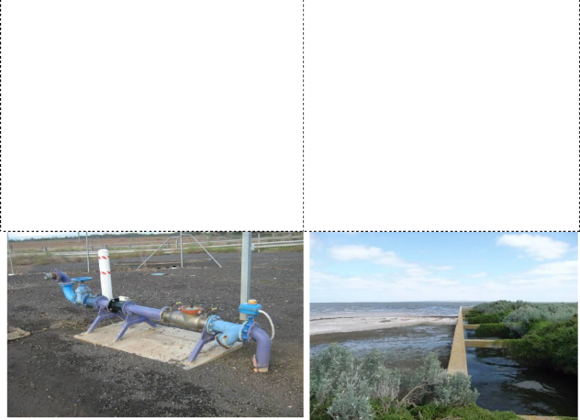

Recycled water standpipe Outfall at Port Phillip Bay

Victorian Curriculum and Assessment Authority (VCAA) <http://victoriancurriculum.vcaa.vic.edu.au/> Accessed 14 August 2016.

